
KONERU LAKSHMAIAH EDUCATION FOUNDATION
(Deemed to be University estd, u/s, 3 of the UGC Act, 1956) Green Fields, Guntur District, A.P., India – 522502
Department of Electronics and Communication Engineering
(DST - FIST Sponsored Department)
Course Code: 24SDEC01R Program: B.Tech - ECE
Course Title: ELECTRONIC SYSTEM DESIGN Academic Year: 2025-26- II/IV-II Sem

SKILL EXPERIMENTS RESULTS
STUDENT NAME: Y.Harshavardhan STUDENT ID: 2400040454
EXP. No.: 7 DATE:

TITLE OF THE EXPERIMENT: Designing Electronic Circuit Protection

AIM: To design and implement a PCB for electronic circuit protection using the
opto-isolator MOC5010 and EasyEDA.

COMPONENTS REQUIRED:
EasyEDA software
A computer with an internet connection
A schematic of the

CIRCUIT DIAGRAM:
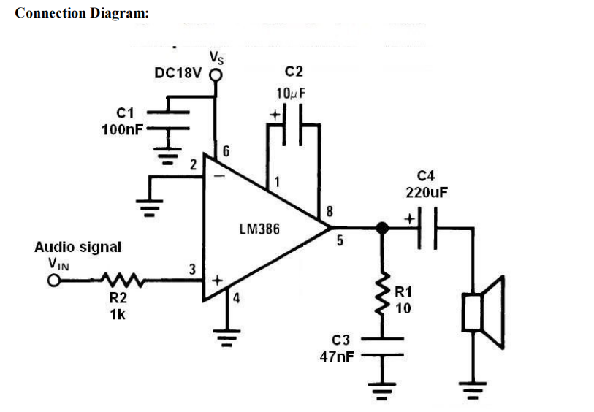
SCHEMATIC:
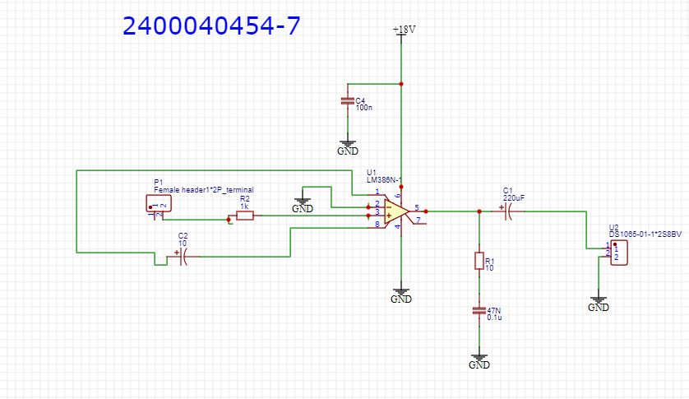

PCB LAYOUT:
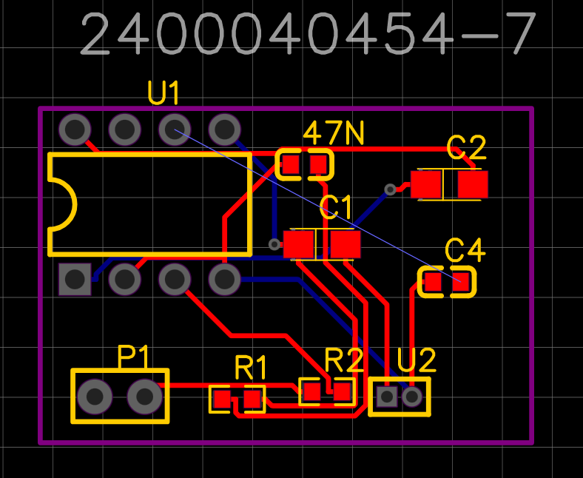
2D VIEW:

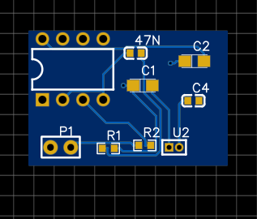

3D VIEW:
